ICSG PRESS RELEASE Date Issued: 19 July 2012

9
ICSG Directory of Global Copper First Use Capacity: 2012 Edition

The International Copper Study Group released its 2012 edition of the “Directory of Copper and Copper Alloy Fabricators – First Use”. This directory provides a systematic global overview of companies and plants involved in the “first use” of copper - the use of unwrought copper materials (refined copper, alloy ingots, direct melt scrap, etc.) as feed to the production of semi-fabricated products (copper wire rod; copper and copper alloy, sheet, strip, bar, rod, tube, etc.). The Directory covers wire-rod plants, brass mills, and electrodeposited copper foil mills. It also covers ingot makers, chemical plants and master alloy plants as suppliers to foundries and brass mills.

Global copper and copper alloy semifabrication production capacity reported in the 2012 edition of the Directory totalled over 46.5 million tonnes in gross weight. This capacity includes all plants in operation and construction reported in 2012 and some projects in early stages. The global semifabrication capacity reported in 2012 consists mainly of 23.3 million tonnes of wire rod capacity, representing 50% of the capacity reported in 2012. If we add close to 1.8 million tonnes of alloy wire capacity reported worldwide in 2012, representing close to 4% of the known capacity, copper and copper alloy wire represents 54% of the global capacity reported this year. Production capacity of flat products, including plates, sheets and strips (PSS) is the second most important source of fabrication capacity worldwide and increased to over 6 million tonnes of capacity reported in 2012 year, representing nearly 13% of the global semifabrication capacity reported. Meanwhile rods, bars and sections (RBS) is the third most reported category with more than 5.28 Mt reported in 2012, or 11 % of the global capacity. However is important to highlight that we did not find significant expansion of capacity for rods, bars and sections products in the 2012 edition in relation to the 2011 edition. The case of copper and copper alloy tube production capacity reported this year is different: we are reporting 4.84 million tonnes of capacity in 2012, growing from 4.7 Mt reported worldwide in 2011. As in 2011, a large number of fabricators and data sources are not reporting plant capacities by product but as aggregated plant capacity, so we have over 3.5 Mt of semis capacity unclassified but with their plant location identified in the 2012 edition.

The Directory is available for sale to ICSG member country/non-member country clients at a price of €400/€600 respectively. An order form is attached to this press release.

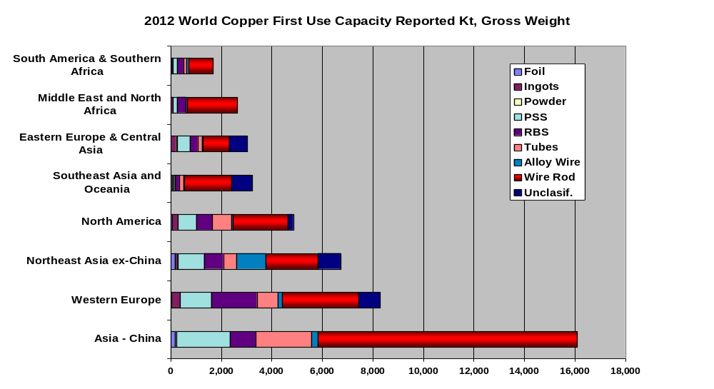

International Copper Study Group Order Form
Prices are quoted in Euros. For US dollars payments contact ICSG (see below)

PUBLICATION | Member Country | Non-Member Country | Total
ICSG Directory of Copper & Copper Alloy Fabricators: 2012 Edition | €400 | €600 | ______€
- 20% discount for Copper Bulletin subscribers |  |  | -_____€
TOTAL ORDER |  |  | ______€

NOTE: ICSG members refer to orders originating from institutions based in ICSG member countries. ICSG member countries are: Australia, Belgium, Chile, China, Finland, France, Germany, Greece, India, Iran, Italy, Japan, Luxembourg, Mexico, Peru, Poland, Portugal, Russian Fed., Serbia, Spain, Sweden, the U.S.A and Zambia.

Name___________________________________________ Title ______________________________________

Company___________________________________________________________________________________

Address____________________________________________________________________________________

City _______________________ Postal Code_________________ Country___________________________

Tel ___________________ Fax__________________ E-mail______________________________________

Date _______________________________ Signed____________________________________________

METHOD OF PAYMENT
□ I enclose a cheque payable to the International Copper Study Group of _____________ Euros addressed to:
International Copper Study Group
R. Almirante Barroso, nº 38, 6th Floor
1000-013 Lisbon, Portugal

□ Please debit my VISA/Master Card for ________________ Euros

Card number

C.V.V. (Card Value Verification - last three digits of the number on the back of the card)

Cardholders Name _______________________________________ Expiry date ____________________

Signature ______________________________________________ Date: ________________________

Cardholders Address _______________________________________________________________________

US dollar payments and electronic bank transfers may be possible. Please contact the ICSG for details.
e-mail: mail@icsg.org tel: 351-21-351-3870 fax: 351-21-352-4035

